

**Report Of EcoSphere Essentials**

Name: MD. Arif Billah

Batch: 41

ROLL 01-041-04

Date: 07/12/2024

Contents

❖ **Executive Summary** 2

❖ Product And Services 2

❖ **Business Plan** 4

❖ Sales and Cost Statistics 5

# **Executive Summary**

EcoSphere Essentials is an online business that specializes in selling eco-friendly, sustainable lifestyle products. The store offers a wide range of items, including reusable household goods, biodegradable packaging solutions, and plastic-free personal care products. The mission is to help individuals and businesses reduce their environmental footprint by providing high-quality, affordable alternatives to traditional products.

Through a sleek, user-friendly e-commerce platform, EcoSphere Essentials connects environmentally conscious consumers with curated products from verified sustainable brands. In addition to the store, the business runs a blog and newsletter offering tips for green living, DIY sustainability projects, and updates on environmental issues.

1. **Sustainability-First Focus**: All products meet strict eco-friendly criteria and are sourced responsibly.
2. **Transparency**: Detailed product sourcing information and certifications are provided for every item.
3. **Community Engagement**: Customers can participate in recycling programs and earn rewards for eco-conscious actions.

The business generates revenue through product sales, affiliate partnerships with green brands, and a subscription box offering curated monthly sustainability products. Its vision is to empower consumers to make choices that contribute to a healthier planet.

# Product And Services

**Products:**

EcoSphere Essentials focuses on high-quality, eco-friendly alternatives to everyday products, catering to individuals and small businesses looking to adopt sustainable practices. The product categories include:

1. **Reusable Household Goods**:
   * Bamboo utensils and straws.
   * Reusable silicone food storage bags.
   * Beeswax wraps for food preservation.
   * Glass or stainless steel water bottles.
2. **Plastic-Free Personal Care**:
   * Shampoo and conditioner bars.
   * Bamboo toothbrushes and biodegradable dental floss.
   * Refillable deodorants and skincare products.
   * Compostable razors.
3. **Eco-Friendly Cleaning Supplies**:
   * Plant-based, biodegradable detergents.
   * Reusable cleaning cloths made from recycled materials.
   * Concentrated cleaning tablets (just add water).
4. **Zero-Waste On-the-Go Items**:
   * Compact reusable cutlery sets.
   * Foldable shopping bags made of recycled fabric.
   * Travel-friendly coffee mugs and collapsible containers.
5. **Sustainable Packaging Supplies**:
   * Compostable mailers for small businesses.
   * Recyclable tape and biodegradable void fillers.
   * Plant-based ink labels.

**Services:**

1. **Subscription Box**:
   * **EcoStarter Kit**: Monthly curated boxes featuring eco-friendly essentials. Perfect for those beginning their journey toward sustainability.
2. **Recycling Program**:
   * Customers can send back used products (like old bamboo toothbrushes or razor heads) for proper recycling or upcycling through partner organizations.
3. **Educational Content**:
   * **Blog and E-Guides**: Tips on living sustainably, DIY eco-projects, and guides to reducing waste.
   * **Workshops/Webinars**: Online sessions for individuals and businesses on topics like “Sustainability in the Workplace” or “Transitioning to a Zero-Waste Home.”
4. **Eco-Consulting Services**:
   * Tailored advice for small businesses on reducing their carbon footprint, switching to sustainable packaging, or implementing green initiatives.
5. **Affiliate Program**:
   * A partnership program allowing eco-conscious influencers and creators to promote EcoSphere Essentials and earn commissions.
6. **Rewards Program**:
   * Customers earn points for purchases, recycling program participation, and referrals, redeemable for discounts or free products.

Go to here and see our products and services: [EcoSphere Essentials](https://ecosphere.co.in/)

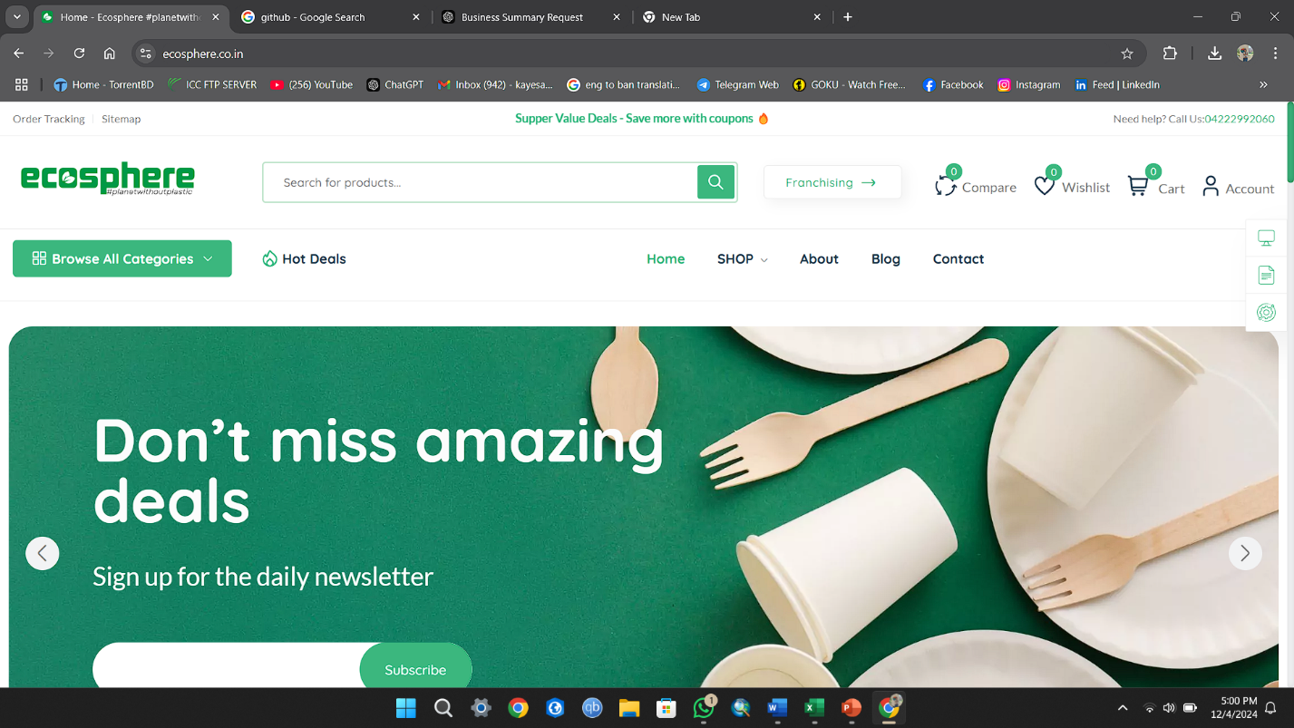

# **Business Plan**

# Sales and Cost Statistics

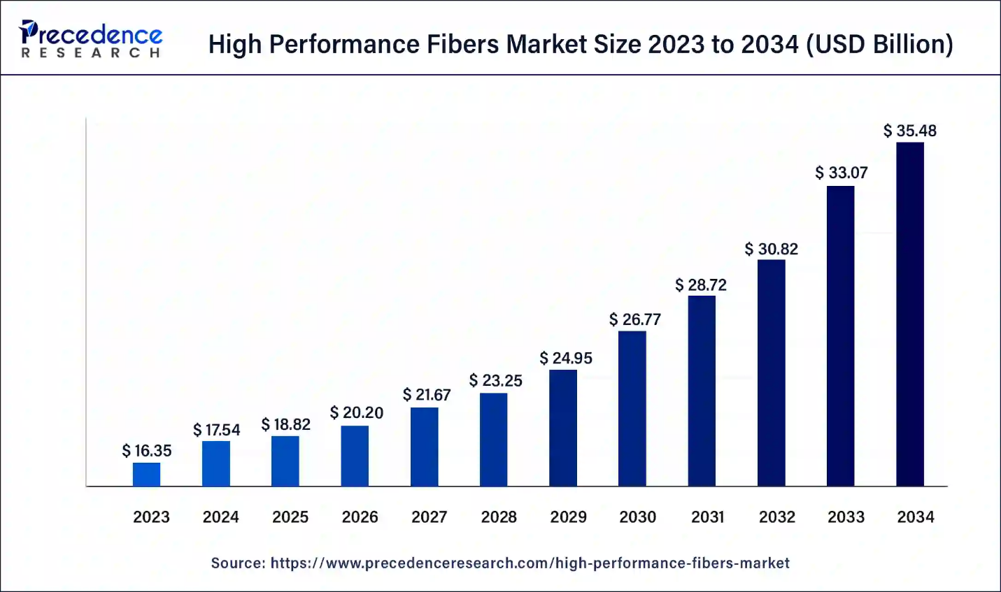

|  |  |
| --- | --- |
| Year | Revenue |
| 2023 | $16.35 |
| 2024 | $17.54 |
| 2025 | $18.82 |
| 2026 | $20.20 |
| 2027 | $21.67 |
| 2028 | $23.25 |
| 2029 | $24.95 |
| 2030 | $26.77 |
| 2031 | $28.72 |
| 2032 | $30.82 |
| 2033 | $35.48 |